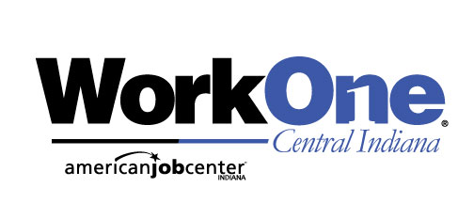
FOR THESE JOB OPENINGS
Week of July 10th , 2023
www.IndianaCareerConnect.com
7/11 – 1:00 pm / Resume, Cover Letter & Thank You - Employer Focused: Do you know the latest strategies for effective employer focus and delivery? | Follow us on Twitter  @NoblesvilleW1 | 7/12 – 1:00 pm / Interview with Your Star Skill Stories: Learn how to demonstrate in an interview that you have had achievements using skills needed by the employer.
Apex Systems, Inc  Job #: 10378903  Job Title: .NET Mobile Developer | Ivy Tech Community College  Job #: 10379961  Job Title: Department Chair for Life and Physical Sciences | Facility Solutions Group Inc.  Job #: 10379302  Job Title: Apprentice Electrician
O'Malia's Living  Job #: 10378788  Job Title: Sales Consultant | Ivy Tech Community College  Job #: 10379711  Job Title: Director of Financial Aid (Hamilton County) | Center For Diagnostic Imaging  Job #: 10377886  Job Title: East Front Office
Foundever  Job #: 10377882  Job Title: Customer Service Representative | Convergint Technologies, LLC  Job #: 10379528  Job Title: Security Technician 2 | ResCare  Job #: 10380338  Job Title: LICENSED PRACTICAL NURSE
BAYADA Home Health Care  Job #: 10380118  Job Title: Registered Nurse (RN) | Sunbelt Rentals  Job #: 10378960  Job Title: Mechanic 2 | TruGreen Limited Partnership  Job #: 10378396  Job Title: Lawn Specialist
ResCare  Job #: 10379904  Job Title: Chaplain - PRN | First Busey Corporation  Job #: 10379005  Job Title: Commercial Syndication Manager | Comprehensive Pharmacy Services  Job #: 10376073  Job Title: Director of Pharmacy
Trilogy Health Services  Job #: 10378851  Job Title: RN - Registered Nurse | Pep Boys  Job #: 10378437  Job Title: Auto General Service Technician | Fastenal Company  Job #: 10378599  Job Title: Buyer
ResCare  Job #: 10380324  Job Title: Area Supervisor | DaVita  Job #: 10379909  Job Title: Patient Care Technician | Red Bull North America  Job #: 10380271  Job Title: Sales Trainee
Verizon  Job #: 10379273  Job Title: Retail Sales Associate | Follow us on Twitter  @HamiltonCoW1 | Curium  Job #: 10379014  Job Title: Manager Quality Assurance
WorkOne/WIOA Title 1 provides equal opportunity programs. Auxiliary aids and services are available upon request to
individuals with disabilities. The Hearing-Impaired Relay Service is available at: 1-800-743-3333

